Covid-19 Project Using
Pyspark Docker with S3

Step 1: S3 bronge layer – raw CSV files
- Opened the AWS S3.
- Created and opened my bucket: covid-analytics-2026.
- Created folder hirerchy covid/bronze-layer/ and navigated there.
- Opened each folder and captured the CSV files:
- nytimes/us_states.csv
- covid_tracking/states_daily.csv
- static/states_abv.csv
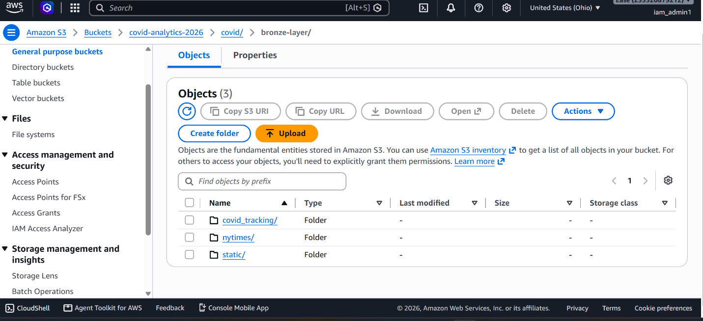

Then after that I loaded all datasets into Spark using S3’s buckets Accesskey and Secret key

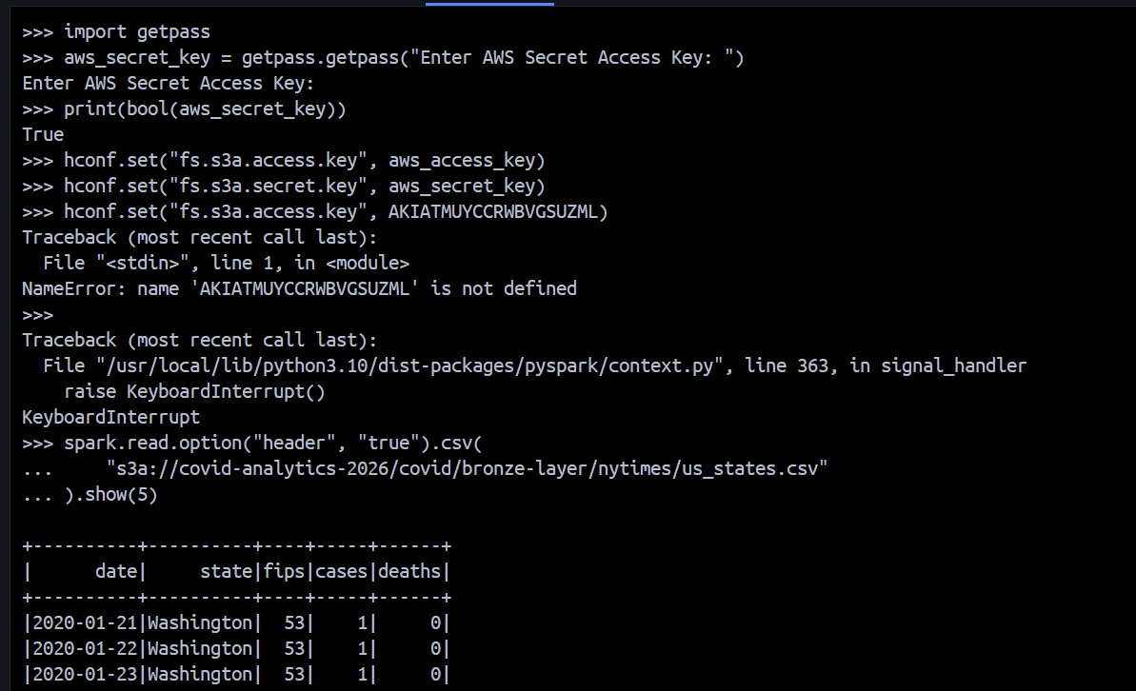

Step 2: Cleaned the original data and converted to Silver layer
In previous step I loaded all three cldata sets from S3 to Pyspark.
Then I cleaned it by revoding leading and trailing spaces from values in every column, removed completely duplicated rows, created cleaned data frames and left the original bronze files unchanged.
Finally I overwrote that cleaned data in Parque format instead of CSV. I mean transferred the cleaned data from Pycharm to S3 bucket. Lets view it in S3

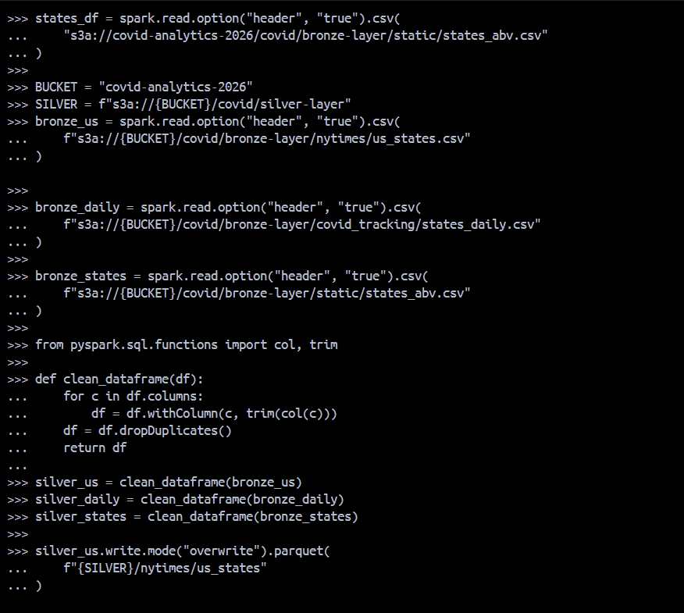

Now Lets move back to S3 to view the Silver layer data in parque format
- In my bucket, navigateed to covid/silver-layer/.
- Captured the three folders:
- nytimes/us_states/
- covid_tracking/states_daily/
- static/states_abv/

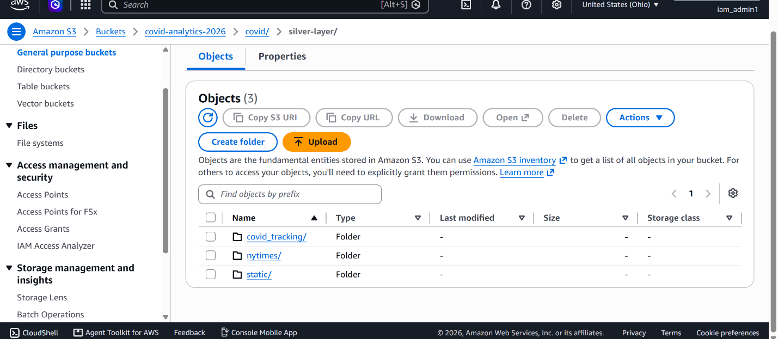

Step 3: Gold layer analytics
First, defining the gold destination in my current Pyspark
Then cheking the column names by printing only the column names, not the rows of data. We need these names to choose the correct join keys and avoid errors when creating the Gold dataset.
Next, preparing the dataset for joining ‘nytimes and ‘dailytracking’ datasets on date and state then adding the state abbreviation.
What this creates: One analytics dataset combining reported cases and deaths from NYTimes with testing, hospitalization, and recovery metrics from the daily tracking data, plus state abbreviations.
The join keeps every NYTimes row even if a matching daily tracking record is unavailable. The final deduplication retains one row per date and state.

